**Difference Between Value & Reference Type Parameter**

using System;

namespace ConsoleApplication1

{

class Program

{

public static void val(int n){

n++;

}

public static void refer(ref int n)

{

n++;

}

static void Main(string[] args)

{

int n;

Console.WriteLine("Enter a value it ");

n = Convert.ToInt32(Console.ReadLine());

Console.WriteLine("\nValue type parameter");

Console.WriteLine("\nValue of n before calling fuction is {0}",n);

Program.val(n);

Console.WriteLine("\nValue of n after calling function is {0}", n);

Console.WriteLine("\nReference Type parameter");

Console.WriteLine("\nValue of n before function calling is {0}", n);

Program.refer(ref n);

Console.WriteLine("\nValue of n after function calling is {0}", n);

Console.ReadLine();

}

}

}

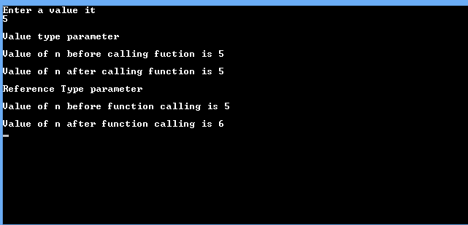

**Swapping Program**

using System;

namespace ConsoleApplication1

{

class Program

{

public static void swap(ref int a,ref int b){

int c = a;

a = b;

b = c;

}

static void Main(string[] args)

{

int x = 10, y = 20;

Console.WriteLine("x = {0}, y = {1}", x, y); //before function calling

swap(ref x, ref y);

Console.WriteLine("x = {0}, y = {1}", x, y); //after function calling

Console.ReadLine();

}

}

}

